TH984 Performance Project

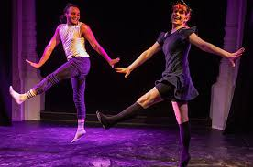



Module Handbook

Spring Term 2025

Dr Cameron Abbott-Betts

Th984 Performance Project

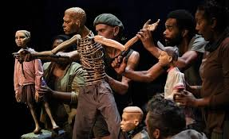

Module Tutor: Dr Cameron Abbott-Betts

Email: [c.abbott-betts@essex.ac.uk](mailto:c.abbott-betts@essex.ac.uk)

Office Hour: Weds 12:30-14:30pm

This module offers students the opportunity to focus on a small-scale performance project that will be suitable for studio spaces, community venues, and/or touring to fringe festivals in the UK and beyond. Driven by their own interests and strengths, students will form small companies to develop, rehearse, perform, and pitch short performances of 45-60 minutes. In addition, each company will develop marketing materials, a budget, and technical specifications.

The module will provide further professionalisation support through a partnership with Colchester Fringe Festival and its director Dr Cameron Abbott-Betts. Performances will premiere in a mini-festival at the Lakeside Theatre, in front of an invited audience and including a post-show Q&A and critique.

We anticipate inviting specialist drama practitioners to deliver certain sessions in e.g. producing small-scale work for studio spaces, community venues, and/or festivals; intimacy and movement choreography; applying for funding; and any other areas of particular specialism that students require.

The aim is that this module will be responsive to student need. We will programme bespoke sessions with local and London-based freelance drama practitioners as required.

The aims of this module are:

* To equip students with the necessary skills and experience to develop, rehearse, produce, and tour a show suitable for studio spaces, community venues, and/or fringe festival venues.

* That by the end of the module, students will have a complete package with which they can pitch their show to venues and/or festivals, including Colchester Fringe.

By the end of this module, students will be expected to be able to:

1. Select or devise and develop appropriate material for a studio, community or fringe festival venue.

1. Work collaboratively in a small company to produce a performance from start to finish, including para-theatrical materials such as marketing copy and a budget.

1. Research, understand and complete funding applications.

1. Pitch their show to an appropriate studio, community venue or fringe festival (including Colchester Fringe and other festivals in the UK and around the world).

|  |  |  |  |
| --- | --- | --- | --- |
| Coursework | Paperwork: Marketing Copy, Touring Budget, and Technical Specifications sheets (due in Week 25: 21/03/2025 on FASer) 25% module assessment. |  | 25% |
| Practical | Performance and Public Q&A (in Week 24) Performed In-class. 70% module assessment. |  | 70% |
| Practical | Participation, Professionalism and Collegiality (continuously assessed) 5% module assessment. |  | 5% |

Week by week Outline

16: Introductions: your work so far. The history and theory of Fringe festivals

Reading: *Forest fringe: the first ten years –* pdf on Moodle (pp 10-41)

17: Devising, improv and collaborative processes.

18: - Dramaturgy, scriptwriting and adaptation. [Class rescheduled (tbc)]

19. Students perform work in progress.

20: Design and technical aspects. Venues – approaching and pitching a show

21: Budgeting and Marketing

22: Technical introduction to Lakeside Theatre. Funding Applications.

23: Rehearsals and sharing of work-in-progress

24: Assessed Performances in Lakeside Studio for audience

Plus Q and A.

25: Marketing Copy, Touring Budget, and Technical Specifications due in by end of the week this week